

Practices for Secure Software Report

Table of Contents
Document Revision History 3
Client 3
Instructions 3
Developer 4
1. Algorithm Cipher 4
2. Certificate Generation 4
3. Deploy Cipher 4
4. Secure Communications 4
5. Secondary Testing 4
6. Functional Testing 4
7. Summary 4
8. Industry Standard Best Practices 4

Document Revision History
Version | Date | Author | Comments
1.0 | October 17, 2026 | Eryn McCarter Penney | Secure communications, SHA256 checksum, and testing results documented.
Client
Artemis Financial

Developer
Eryn McCarter Penney

- Algorithm Cipher
The original application needed a reliable way to create a checksum that could be used to verify data. I updated the Spring Boot application to provide a /hash endpoint that uses the SHA256 message digest algorithm. SHA256 produces a fixed length digest from the supplied data. It is appropriate for checking whether data has changed, although a checksum by itself does not encrypt data or prove who sent it. The endpoint hashes a consistent verification string so I can confirm that the same input produces the same output when the page is refreshed.

- Certificate Generation
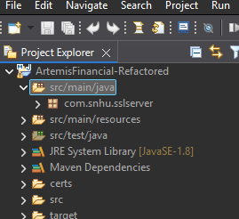
Eclipse project view showing the refactored project and certificate folder.

I configured a local certificate and keystore for HTTPS testing. The project uses a PKCS12 keystore with an RSA 2048bit key and a certificate for localhost and 127.0.0.1. The exported CER file can be used to view or import the certificate. This is a selfsigned development certificate, so a browser may display a security warning because it is not issued by a publicly trusted certificate authority. That warning does not mean the HTTPS endpoint failed to start.

- Deploy Cipher 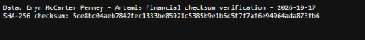
Browser evidence showing the SHA256 checksum endpoint.

I ran the refactored Spring Boot application and opened https://localhost:8443/hash in a browser. The endpoint displayed the verification data and its SHA256 checksum. I refreshed the page and checked that the checksum remained the same for the same input. This confirmed that the endpoint was reachable and that the digest was repeatable for the test string.

- Secure Communications
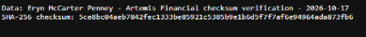
Browser evidence showing the local HTTPS endpoint.

The application was configured to use HTTPS on port 8443 with the local keystore. HTTPS uses TLS to protect data while it travels between the browser and the server. The local browser test demonstrated that the application could be reached over an HTTPS URL. Because the certificate is selfsigned and is only for local testing, the browser may label the page as not secure until the certificate is trusted. For a production deployment, the service should use a certificate issued by a trusted certificate authority, protect the private key, and keep the TLS configuration and dependencies maintained.

- Secondary Testing
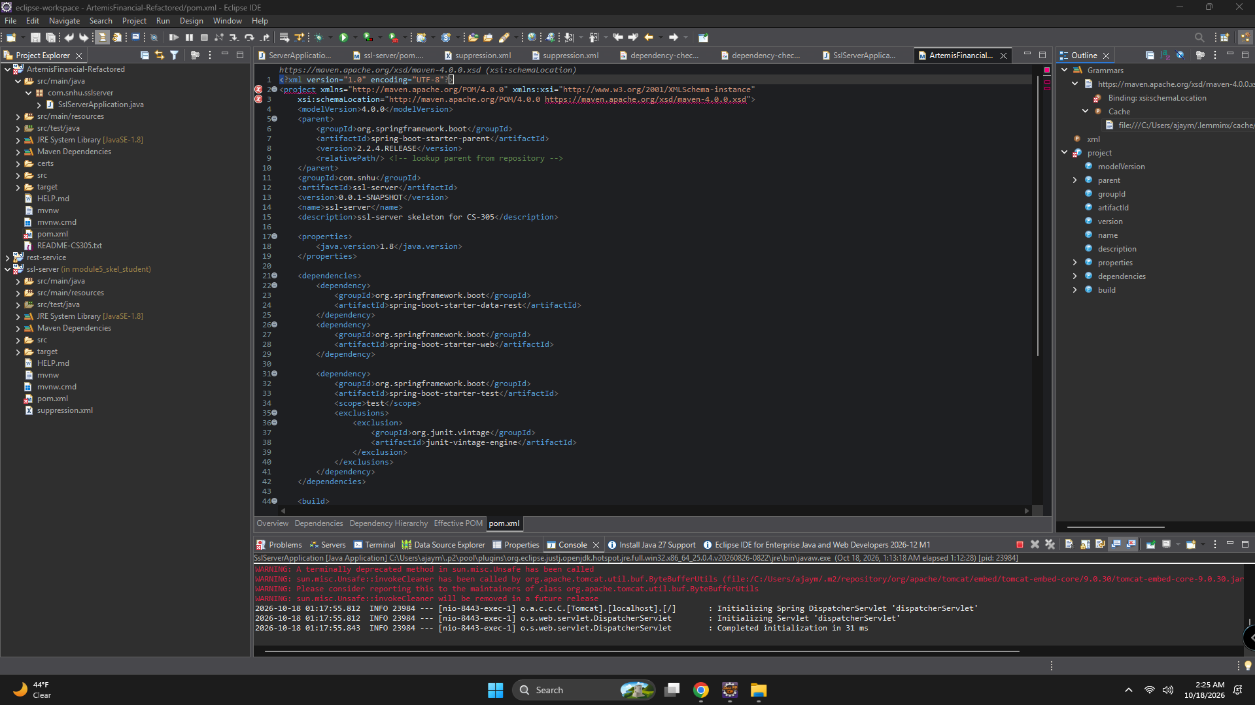

Eclipse evidence from the local application/build workflow; DependencyCheck did not complete.

I ran a Maven package build on the modified ArtemisFinancialRefactored project using clean package DskipTests, and Maven reported BUILD SUCCESS. I also attempted to run OWASP DependencyCheck. The scan did not complete: the earlier attempt using the old plugin version could not retrieve NVD vulnerability metadata because the server returned HTTP 403. After updating the plugin to version 12.1.0, Maven began downloading plugin dependencies and vulnerability data, but I stopped the run because it was taking too long. Therefore, I do not have a completed DependencyCheck report and cannot claim that the scan passed. The scan should be rerun when network access and sufficient time are available.

- Functional Testing
Eclipse evidence from the application running in the development environment.

I launched SslServerApplication from the ArtemisFinancialRefactored project. The Eclipse console showed Spring Boot starting with HTTPS on port 8443, and the browser successfully loaded the /hash endpoint. The displayed checksum was stable after refreshing the page. I also ran Maven's clean package goal with tests skipped and received BUILD SUCCESS, which confirms that the project compiled and packaged. This does not replace automated unit tests or a completed dependency vulnerability scan.

- Summary
This project improved the application's handling of secure communications and data integrity checking. I configured HTTPS for local testing, created a certificate and keystore, and added a SHA256 checksum endpoint. I verified that the application started and that the checksum endpoint returned a consistent result. Maven successfully packaged the modified project. The remaining limitation is the DependencyCheck scan, which could not be completed during this session because vulnerability data retrieval and plugin downloads took too long. That result is documented as incomplete rather than reported as a successful scan.

- Industry Standard Best Practices
Secure software development should use multiple layers of protection. Sensitive traffic should be sent over HTTPS with a certificate trusted by clients, modern TLS settings, and securely stored private keys. Cryptographic functions should be chosen for their intended purpose: SHA256 can help detect changes, but it is not encryption and does not authenticate a user. Input should be validated, errors should not reveal secrets, and dependencies should be reviewed and updated to address known vulnerabilities. Automated tools such as OWASP DependencyCheck are useful, but their results must be reviewed and the scan must actually finish before its findings can be reported. Code review, repeatable builds, functional testing, least privilege, and secure configuration should be part of the ongoing development process.

